**ABHIJIT DASH**

**RA1811031010112**

**NFA TO DFA**

**AIM:-**

Conversion from Non-Deterministic Finite Automata(NFA) to Deterministic Finite Automata(DFA).

**CODE:-**

import pandas as pd

# Taking NFA input from User

nfa = {}

n = int(input("No. of states : ")) #Enter total no. of states

t = int(input("No. of transitions : ")) #Enter total no. of transitions/paths eg: a,b so input 2 for a,b,c input 3

for i in range(n):

state = input("state name : ") #Enter state name eg: A, B, C, q1, q2 ..etc

nfa[state] = {} #Creating a nested dictionary

for j in range(t):

path = input("path : ") #Enter path eg : a or b in {a,b} 0 or 1 in {0,1}

print("Enter end state from state {} travelling through path {} : ".format(state,path))

reaching_state = [x for x in input().split()] #Enter all the end states that

nfa[state][path] = reaching_state #Assigning the end states to the paths in dictionary

print("\nNFA :- \n")

print(nfa) #Printing NFA

print("\nPrinting NFA table :- ")

nfa_table = pd.DataFrame(nfa)

print(nfa_table.transpose())

print("Enter final state of NFA : ")

nfa_final_state = [x for x in input().split()] # Enter final state/states of NFA

###################################################

new_states_list = [] #holds all the new states created in dfa

dfa = {} #dfa dictionary/table or the output structure we needed

keys_list = list(list(nfa.keys())[0]) #conatins all the states in nfa plus the states created in dfa are also appended further

path_list = list(nfa[keys_list[0]].keys()) #list of all the paths eg: [a,b] or [0,1]

###################################################

# Computing first row of DFA transition table

dfa[keys_list[0]] = {} #creating a nested dictionary in dfa

for y in range(t):

var = "".join(nfa[keys_list[0]][path_list[y]]) #creating a single string from all the elements of the list which is a new state

dfa[keys_list[0]][path_list[y]] = var #assigning the state in DFA table

if var not in keys_list: #if the state is newly created

new_states_list.append(var) #then append it to the new_states_list

keys_list.append(var) #as well as to the keys_list which contains all the states

###################################################

# Computing the other rows of DFA transition table

while len(new_states_list) != 0: #consition is true only if the new_states_list is not empty

dfa[new_states_list[0]] = {} #taking the first element of the new_states_list and examining it

for _ in range(len(new_states_list[0])):

for i in range(len(path_list)):

temp = [] #creating a temporay list

for j in range(len(new_states_list[0])):

temp += nfa[new_states_list[0][j]][path_list[i]] #taking the union of the states

s = ""

s = s.join(temp) #creating a single string(new state) from all the elements of the list

if s not in keys_list: #if the state is newly created

new_states_list.append(s) #then append it to the new_states_list

keys_list.append(s) #as well as to the keys_list which contains all the states

dfa[new_states_list[0]][path_list[i]] = s #assigning the new state in the DFA table

new_states_list.remove(new_states_list[0]) #Removing the first element in the new_states_list

print("\nDFA :- \n")

print(dfa) #Printing the DFA created

print("\nPrinting DFA table :- ")

dfa_table = pd.DataFrame(dfa)

print(dfa_table.transpose())

dfa_states_list = list(dfa.keys())

dfa_final_states = []

for x in dfa_states_list:

for i in x:

if i in nfa_final_state:

dfa_final_states.append(x)

break

print("\nFinal states of the DFA are : ",dfa_final_states) #Printing Final states of DFA

**OUTPUT:-**

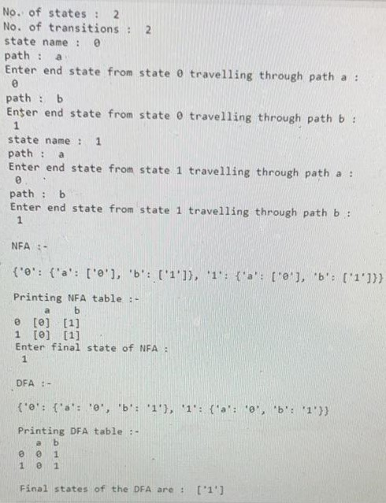

**RESULT:-**

The given expression has successfully been converted from NFA to DFA.